
University Institute of Engineering Department of Computer Science & Engineering
DM (CST-352/ITT-352)

Assignment-3

Questions for slow Leaner’s

Q1 The Breadth-First Search algorithm has been implemented with the help of a queue. What is a possible order of visiting the nodes of the following graph is
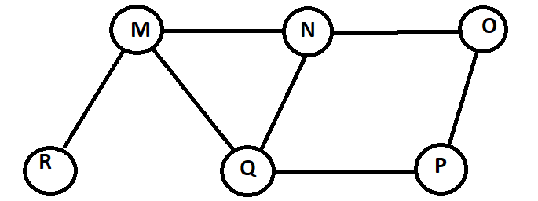
Q3 Construct the minimum spanning tree (MST) for the given graph using Kruskal’s Algorithm-
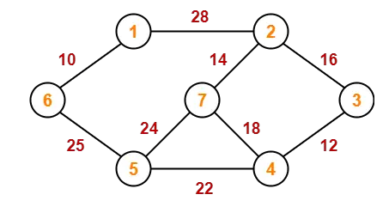. (CO-5)

Q4. Convert the following expression to canonical Sum-of=Product form :
(a) X + X’Y + X’Z’ (b) YZ + X’Y (c) AB’ (B’+C’)
Convert the following expression to canonical Sum-of=Product form :
(a) X + X’Y + X’Z’ (b) YZ + X’Y (c) AB’ (B’+

Instructions
- Each Question carries 2.5 Marks
- High Plagiarism can result into cancellation of Assignment.
- Try to explore your answer with your creative thinking.
- All Assignments should be written on A4 sheets left hand side scaled manually and strictly written one side only.
- All Assignment must have front page entitled your name, UID number, Batch/Group

